**Exp 04: Create a simple cloud software application for Library book reservation**

**system for SIMATS library using any Cloud Service Provider to demonstrate**

**SaaS.**

**Aim**

To design and implement a simple cloud-based Library Book Reservation System for SIMATS library using Zoho Creator as a Cloud Service Provider, thereby demonstrating the Software as a Service (SaaS) model.

**Procedure**

1. Login to Zoho Creator → Create a new application named *“SIMATS Library Reservation System”*.
2. Create Forms → Build forms such as *Student Registration*, *Book Catalog*, *Reservation Request*, and *Issue/Return*.
3. Define Fields → Add fields like Student Name, ID, Book Title, Author, Date of Reservation, Issue Date, Return Date.
4. Set Workflows → Automate approval when a student reserves a book and send email/SMS notifications.
5. Design Reports → Generate reports such as *Available Books*, *Reserved Books*, and *Overdue Returns*.
6. Deploy as SaaS → Publish the app, provide cloud access to students and staff, and allow usage through web/mobile.

**Output**

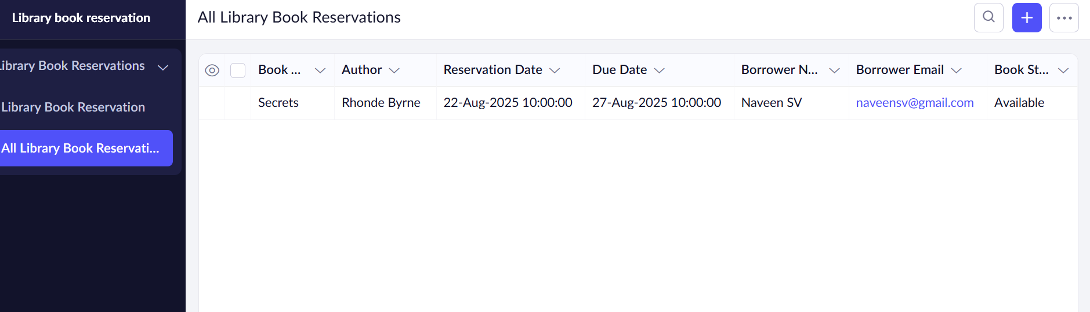

**Result**

A simple cloud-based Library Book Reservation System was successfully created and deployed in Zoho Creator as a SaaS application. Students can reserve, borrow, and return books online, while the library can manage records efficiently.